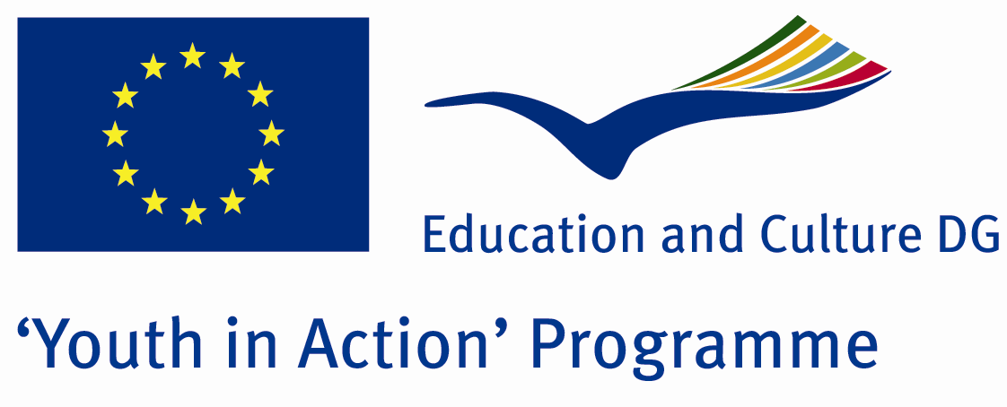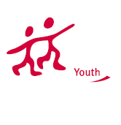

Action 1.1
Project Summary; Smiling faces of life, cheerful people playing creak of the door. How much do we know them? We aim tol define and contribute to solve the problems of Gypsy community. Would you help us?

Project Title; Red Lifes with colourful smiling
Date and Venue ; 01-08 2013 April Turkey
Place: Kırklareli.

Target Group ; Municipalities, City Councils and Non-Governmental organizations,
youth groups,culture and art groups,e.t.c

Participants ; 5 people from each country (over 18 -25 ). Totally 7 countries.

Conditions ; Accommodation, board and programme costs will be financed through European Commission Youth in Action Programme . Travel costs will be reimbursed in 70% (APEX Tarrifs). Organizations from all 27 EU member countries plus Liechtenstein , Norway and Iceland are eligible to take part.

Working language: English

Organisator group: Group Doga

How to apply: If you are interested, please send your Part III forms to
by e-mail please (in word file). Scan Part3 format is enough for application.(Fulfilled Part III which you can find in the attachment, of course signed and stamped) ..

Contact e-mail: groupsymrnes@gmail.com
Group e-mail: groupdogaaa@gmail.com

Deadline to apply:20.09.2012

